[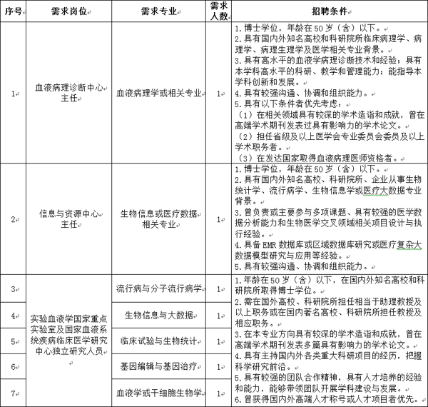](http://www.pumc.edu.cn/wp-content/uploads/2020/03/ge5.jpg)